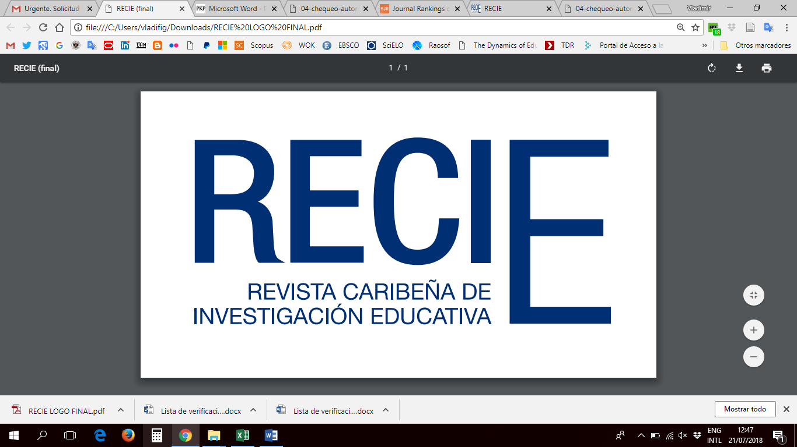

**Presentation and Publication Agreement**

**Insert the title of the article in English** [*The title should be descriptive, clear, brief and concise. It is recommended that it contain between 8 and 15 words and include keywords*]

|  |
| --- |
|  |

|  |
| --- |
| First and last name: ____________________________________________________________  Professional category:________________________  Institution: ________________________________  Department:_______________________________  Mailing Address:________________________________  E-mail: _______________  ORCID: ___________________  O Author of correspondence |

|  |
| --- |
| First and last name: ____________________________________________________________  Professional category:________________________  Institution: ________________________________  Department:_______________________________  Mailing Address:________________________________  E-mail: _______________  ORCID: ___________________  O Author of correspondence |

|  |
| --- |
| First and last name: ____________________________________________________________  Professional category:________________________  Institution: ________________________________  Department:_______________________________  Mailing Address:________________________________  E-mail: _______________  ORCID: ___________________  O Author of correspondence |

**DECLARE(S) UNDER OATH**

1. The author(s) grant the Editorial Committee of the Revista Caribeña de Investigación Educativa of the Higher Institute of Teacher Training Salomé Ureña (ISFODOSU) the right of first publication of their article, subjecting it to the Creative Commons Attribution-NonCommercial-ShareAlike 4.0 International License (CC BY-NC-SA). This license allows third parties to adapt and build upon the published work, as long as it is for non-commercial purposes, they provide appropriate credit to the original author, and indicate if changes were made. Furthermore, any derivative work must be distributed under the same CC BY-NC-SA license. The authors retain their copyright, which facilitates the free distribution and reuse of the article while respecting the terms of the license.
2. The author(s) assure that the article is original, has not been previously published, nor submitted to another publication. It is guaranteed that the article does not contain copyrighted material without the necessary permissions and does not infringe upon third-party rights.
3. The author(s) commit to respecting ethical principles in research and declare no conflicts of interest. Additionally, they commit to presenting primary sources of documentation if requested.
4. Upon acceptance of the article, the author(s) commit to participating in dissemination activities, such as creating a short video related to their research, and to promote their work through various channels, using the link to the journal to facilitate access and reading.
5. In case of claims concerning copyright, the author(s) will assume all legal responsibility.
6. Acceptance of Publication Norms: The author(s) accept the publication norms of the Caribbean Journal of Educational Research, including the open access policy and the use of the CC BY-NC-SA license.

Finally, the authors do not transfer the intellectual property of their work to the journal. Instead, they grant the journal non-exclusive publication rights under the terms of the Creative Commons Attribution-NonCommercial-ShareAlike 4.0 International License (CC BY-NC-SA). This license facilitates collaborative and extensive use of the published article, always respecting the original authorship. This promotes the free circulation of knowledge in the educational field.

Date and signature of the author(s):

|  |  |  |
| --- | --- | --- |
|  |  |  |
| Date: | Date: | Date: |